Chromosome Exploration

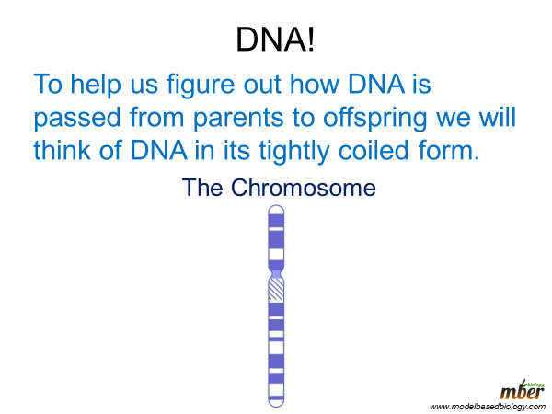
Using the information above answer the following questions:
- What is the material that passes information from parent to offspring?

- What is a chromosome?

Print and use the diagram on the next page for the next part of the activity. If you do not have a printer sketch the circles out on a piece of paper.

Making babies

Print and cut out the chromosomes below. Color the first set red and the second set blue. If you do not have a printer please sketch them out on a piece of paper, you can even just represent them each as a line. Be sure to label the letters and cut each one out so you can move them around individually.

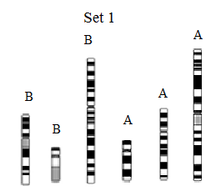

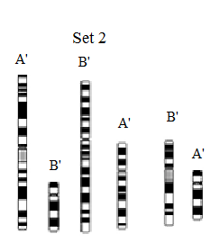

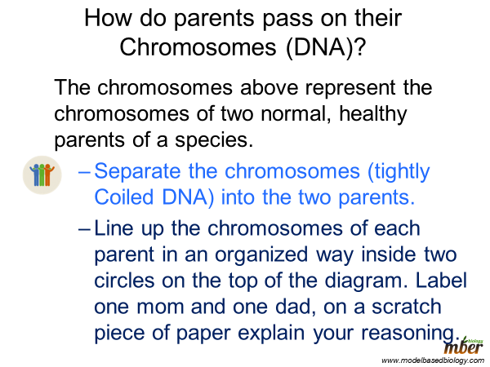
Use the answer Key A from the website to check your work at this point. If you are incorrect fix your diagram to match the key and write a reflection on a scratch piece of paper on what you got wrong and why.
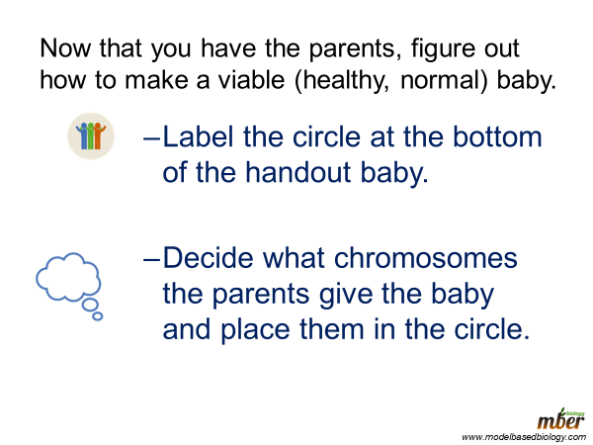

Check your answer with answer Key B on the website (same document as answer Key A). Then look at the other viable and not viable babies in the answer key. Decide on a list of rules or criteria for what makes a baby viable. List these rules on your doodle Sheet in box C or on a separate sheet of paper. Save your chromosomes and all other documents with this assignment for the second part which will be assigned on a later date.

