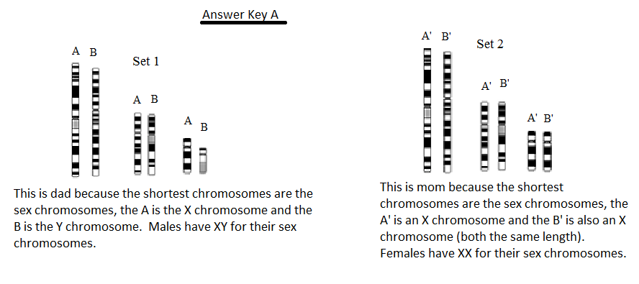

DO NOT SCROLL DOWN, UNTIL LATER…ANSWER KEY B IS BELOW!!!!

ANSWER KEY B IS BELOW…DO NOT PEEK UNTIL YOU ARE READY TO CHECK THIS PART OF THE ASSIGNMENT!!!!

Answer Key B
The following are viable babies, they are not limited to these examples, but here are certain criteria that make them viable.
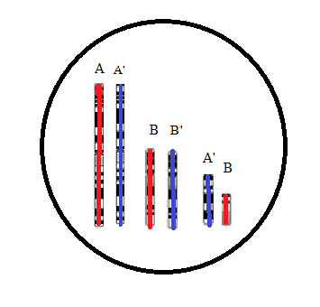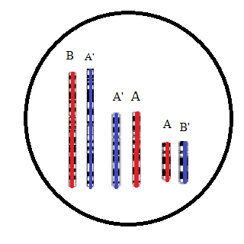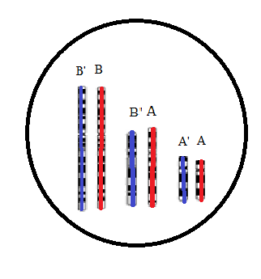
Male Child Female Child Female Child
The following are NOT viable babies, there may be more examples, but these do not fit the criteria for viable babies.
